

SCHOOL BROCHURE 2022-2023

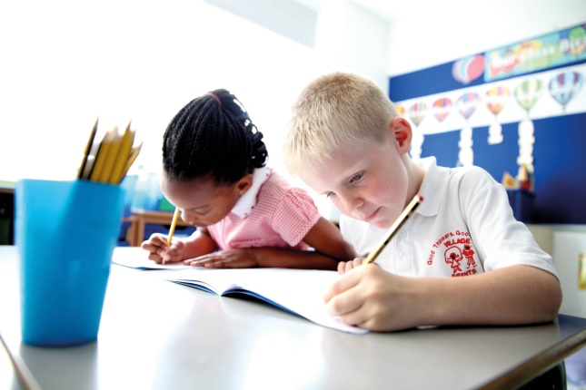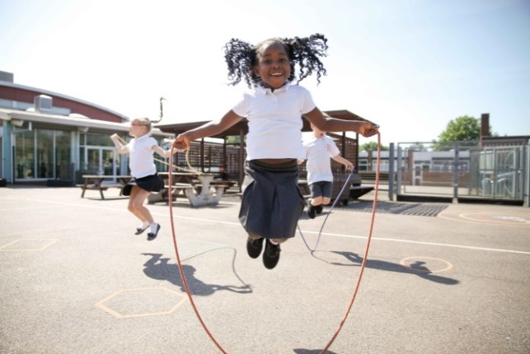
Resilience Perseverance

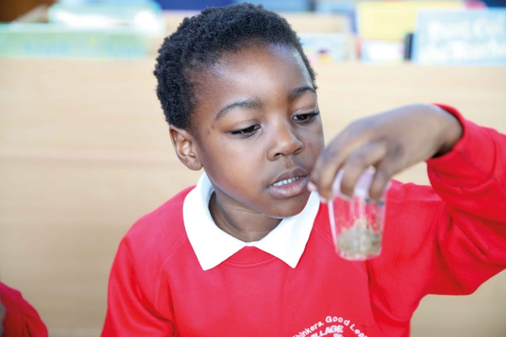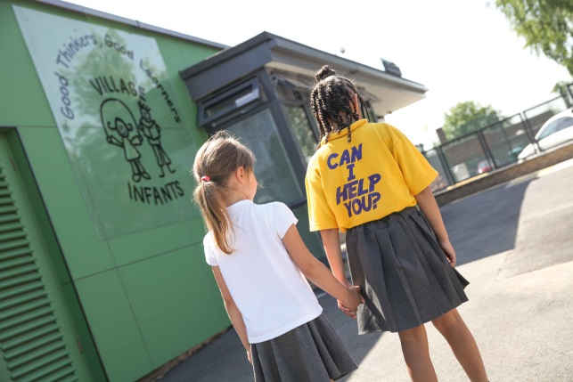
Curiosity Kindness

Telephone: 020 8270 6589
Website: www.villageinfants.com
Twitter: @villageinfants

CONTENTS

HEAD TEACHER’S WELCOME LETTER

SCHOOL VISION

BRITISH VALUES

PHSE STATEMENT

GOVERNING BOARD 1
SESSION TIMES 2
SCHOOL/PARENT CONTACT 3
ADMISSIONS 4
STAFFING 5
RECEPTION CURRICULUM 6
KEY STAGE 1 CURRICULUM 7
READING 8/9
MATHS 9/10
HELPING IN SCHOOL 12
ASSEMBLIES 12
P.E. 13
ATTENDANCE & PUNCTUALITY 13/14
SAFETY 15
E-SAFETY 16
LUNCHTIMES 17
BEHAVIOUR 18
SCHOOL UNIFORM 19
POLICY FOR PUPIL ILLNESS AND MEDICINE 20/21
CHILD PROTECTION 22
SPECIAL EDUCATIONAL NEEDS AND DISABILITIES 23
COMPLAINTS PROCEDURE 24
TERM DATES/HOLIDAY DATES 25
HANDWRITING SCRIPT 26
POEM 27

Dear Parents,

Welcome to Village Infant School. As an infant school we are proud to be able to share your child’s first experience of school with you. We are committed to providing a safe and caring environment for your child to begin their learning journey, where all children can achieve their very best and become lifelong learners.

At Village Infants our core values are:
Perseverance…. Helps us to keep doing something even when it is difficult.
Resilience……… Helps us to feel OK about making mistakes.
Curiosity ………...Makes us eager to learn and ask questions.
Kindness….….….Makes us friendly and considerate of other people’s feelings.

We want our children to understand that when they are kind and considerate to others they feel good themselves. We also believe that children learn best when they feel safe to make mistakes. Children need to perceive difficulty not as a failure but as an opportunity to embrace challenge and learn something new. This allows them to develop perseverance and resilience so that they are eager to learn, willing to try new things and do not give up when ‘the going gets tough!

To achieve this staff and children need to think with a Growth Mindset, to believe that everyone can grow their intelligence, their talents and become smarter.
We do not want our children to say “I can’t do that!”
We want them to say “I can’t do that yet! “

We welcome you to the Village community and look forward to working together to help our children grow.

We hope you find the information in this brochure useful. Please do not hesitate to contact the school office if you have any further questions.

Telephone: 020 8270 6589 Website: www.villageinfants.com

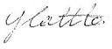
Yours sincerely,

Yolanda Cattle
Acting Headteacher



VILLAGE VISION

Children come to school to grow, to learn, to imrove.
At Village Infant School we celebrate challenge, learn from our mistakes
and grow as learners together.

At Village we promote the fundamental British Values of:

Democracy
Rule of Law
Individual Liberty
Mutual Respect
Tolerance

Democracy by making decisions together

Rule of Law by understanding that rules matter, that our own and others behaviour has consequences and learning to distinguish between right and wrong

Individual Liberty by developing a positive sense of self and understanding that others may have different opinions

Mutual Respect by caring, sharing and listening to others, developing a respect for our own and other cultures

Tolerance of those with different life styles and beliefs than ourselves

British Values

This is how British Values are promoted at Village Infants
Democracy
Democracy and the right to have your views heard, is a core value of the school. All pupils are treated fairly and have an equal right to be listened to and express their views. Our School Council is a focal part of pupil decision making. Members are elected at the beginning of each year to represent the views of their class. Meetings are held with the School Council Lead every half term. Reports of meetings are available on the school website for pupils to share with their parents.
Pupil voice is also facilitated through weekly class assemblies where, whenever the need arises, children are given the opportunity to speak about issues that affect themselves, their class/school.
Parents and Carers are invited to share their views of the school in an annual questionnaire and Parent Voice feedback forms. Parents are always welcome and are encouraged to give their views and attend meetings and curriculum workshops. The Governing Body is comprised of elected representatives from staff, parents, the LA and the community.

Rule of Law
The importance of laws, whether they are those that govern the class, the school, or the country, are consistently reinforced in everyday school life as well as in assemblies, class discussions, and when behaviour issues are dealt with. Pupils are taught to recognise right from wrong. The school rules (kInd hands, kind feet, kind words) are reviewed with pupils at the start of every academic year and pupils may agree on some additional class rules with their teacher. Pupils are taught the reasons behind these rules and supported to keep them. The latter are displayed in the school hall and every classroom. All displays are supported with visual images to ensure all pupils are able to have ownership of them regardless of ability or reading level. Pupils are encouraged to Stop – Think and Choose the Right Thing. Failure to keep school rules comes with a consequence but mistakes are used as opportunities to move forward with more wisdom.

Individual Liberty
Pupils are actively encouraged to develop a positive sense of self and understanding that others may have different opinions. This is done through assemblies, PSHE lessons and E-Safety lessons etc. We educate our young pupils and provide boundaries for them to: Stop – Think and Choose, helping them to make decisions that are acceptable to the school community and society at large. This is reinforced by the school logo: Good Thinkers, Good Learners. Pupils are encouraged to know, understand and exercise their rights and personal freedoms whilst understanding that their choices cannot compromise the rights of others.

Mutual Respect
Pupils learn about specific British celebrations, events and commemorations through assemblies and curricular topics. They learn, at an age relevant level for infants, how important events in history (eg: Remembrance Day) have shaped our lives and what has made Britain and the world what it is today. Inter-faith festivals are also celebrated and our World Celebration Week encourages appreciation of things that are special to others worldwide. Pupils are taught about difference and diversity and also commonalities to help them appreciate the need to treat each other with mutual respect. [School Rules & Behaviour Policy] Sports activities also promote an attitude of equality and fairness.

Tolerance of those with different Faiths and Beliefs
Our RE and PHSE curriculum, World Celebration week, Assemblies, School Rules, School Logo: Good Thinkers, Good Learners and listed policies reinforce the message of tolerance and respect for others. Pupils are taught to feel special about themselves and respect the rights and beliefs of everybody else. They are encouraged to celebrate diversity and are supported by staff to express their feelings, and when necessary, to negotiate with their peers to resolve disagreements.

Our school day provides a wealth of opportunities to enrich the Spiritual, Moral, Social and Cultural development of our pupils to give them the skills essential to be successful citizens in the community in which they live.

Associated Policies:
Behaviour Policy
Equality Plan
Home School Agreement
Safeguarding / Child Protection Policy
Teaching and Learning Policy
Curriculum Policies – RE, PHSE RHE

PSHE Statement

At Village Infants we aim to deliver a Personal, Social Health Education (PSHE) curriculum which is accessible to all and ensures that each of our pupils will know more, remember more and understand more about how to play a positive and successful role within our society, both as children and as an adults in the future.

We deliver a curriculum that encourages our children to be healthy, independent and responsible members of a society, who understand how they are developing personally and socially, and we aim to give them the confidence to tackle many of the moral, social and cultural issues that are part of growing up. We also provide our children with opportunities to learn about rights and responsibilities and to appreciate what it means to be a member of a diverse society. Moreover our children are encouraged to develop their sense of self-worth by playing a positive role in contributing to school life and the wider community. We challenge all of our pupils to look for opportunities to demonstrate the school values of perseverance, resilience kindness and curiosity and actively seek leadership opportunities within our school and within their local community.

In Nursery and Reception, the PSHE will be delivered through the Early Years Statutory Framework- Personal, Social and Emotional Development (PSED). Key Stage 1 will have weekly PSHE lessons that cover three main themes; Health and Wellbeing, Relationships and Living in the Wider World.

For further information please access the school website, Year Group Learning, Curriculum Overview, PSHE.

The Governing Board

The Governors work closely with the Headteacher and staff in monitoring planning and developing the school.

Our present Governors are:-

Jo Archer - Chair of Governors
Co-opted Governor

Kelly Nicholls - Vice Chair of Governors
Co-opted Governor

Yolanda Cattle - Acting Headteacher

Joy Barter - LA Governor

Debbie Rosaman - Staff Governor

Bernadette Thompson - Co-opted Governor

Glen Spoor - Co-opted Governor

Nichola Bridge - Co-opted Governor

Su Joy - Co-opted Governor

Vacancy - Co-opted Governor

Vacancy - Co-opted Governor

Arif Rahman - Parent Governor

Louise Sparks - Parent Governor

Parents can contact the Governors via the school office.
SESSIONS TIMES
Current Start and Finish Times
Drop Off Time: 8.50am – 9.00am
(We would like all children to be in their class ready for learning by 9am) Pick up Time: Playgroud gates open at 3.00pm, children will leave by the classroom doors at 3.10pm
Please note the bollards will be raised the following times. During these times there will be no vehicular access to the school site.
am: 8.45am – 9.15am pm: 3.00pm – 3.30pm
Key Stage 1 Drop Off/Pick Up Times and Place
Year 1 Drop Off
Children enter by the main school gate between 8.50am and 9.00am.
Year 1 Pick Up
Parents enter the playground by the main school gate, which will be opened at 3pm, and wait outside their child’s class. Teachers will let the children out of their classroom door at 3.10pm.

Year 2 Drop Off
Children enter by the Yr 2 gate in the school car park between 8.50am and 9.00am.
Year 2 Pick Up
Parents enter the playground by the Yr 2 gate in the school car park, which will be opened at 3pm, and wait outside their child’s class. Teachers will let the children out of their classroom door at 3.10pm

Reception Drop Off/Pick Up Times and Place

Class | Drop Off Time | Drop Off  Place | Pick Up Time | Pick up Place
Mondeo | 8.50am -9.00am | All Reception classes to enter by the main gate near the driveway which will open at 8.50am. Parents will leave their children at the Reception entrance and then leave the school by the side gate near the Reception entrance, creating a one way system.  The gates will close at 9am. | Gates open -3.00pm  Pick up -3.10pm | Parents will enter through main gate by the driveway, collect their children from class Mondeo and then leave through the same gate.
Cortina | 8.50am - 9.00am |  | Gates open -3.00pm  Pick up -3.10pm | Parents will enter the main school playground (Children's Entrance) and walk round to Cortina class where they will pick up their children. They will then leave the school by the same gate.
Granada | 8.50am - 9.00am |  | Gates open -3.00pm  Pick up -3.10pm | Parents will wait by the side Reception gate to collect their children.

- Arrival - In the interests of safeguarding we expect an adult to wait with their child until they enter the school gate children must not be left unattended.
- Collection - We have a password system for keeping children safe.
- Parents must inform the school office or the member of staff on the gate if their child is to be collected by anyone other than the usual adult. Please ensure the adult collecting your child has your child’s Password. We will not release any child if the password is unknown.
- We will not allow the children to leave the school with anyone under the age of 14
SCHOOL/PARENT CONTACT

Please be sure to inform us immediately of any changes to your contact information as it is most important that our records are kept up-to-date. We must always know where to contact you should an emergency arise
Before school:
- Y1 and Y2 parents may leave messages with the member of staff at the school gate.
- Reception parents can give messages to the Learning Support Assistant at the door.
- Please speak to the school office if you have any matters which you need to discuss. The school office will deal with the matter in the first instance or arrange for an appointment to see the appropriate person if necessary.

After school
- You may speak to your child’s teacher when you collect them after school.

Home/School Agreement - As a parent you have high expectations of the school. We feel that this is a two way process and the school has high expectations of you as a parent. We have a Home/School Agreement that we will ask you to sign. This clearly identifies how we can be effective partners. A copy of this Agreement is at the back of this brochure.

Communication
We send letters to parents via Parent Mail. Once your child has started school the office will send you a link via email for you to register with Parent Mail. Letters are also available to read on the school website [www.villageinfants.com].

After School Clubs
Please see our school Website for information on our After School Clubs [www.villageinfants.com].

OPEN EVENINGS/EVENTS
Open-evenings are held each term. You will be informed of the dates by Parent Mail and invited to make an appointment electronically using Parent Mail. As a school we value the opportunity to be able to discuss your child with you. In order to work as partners it is essential that you attend open evenings.

Website www.villageinfants.com
Please see our School Website for policies and further information. You will also find out on our website what your child is learning in their class and how you can support their learning at home. In the Gallery section of Yeargroup Learning, you will find photos of the children enjoying their learning.

Twitter @villageinfants
As well as our website we also use Twitter as a tool to give you an instant insight into the school day at Village.

ADMISSIONS

Our formal standard number per year group is 90 children (3 classes of 30 children)

The London Borough of Barking and Dagenham admissions criteria are adhered to as follows-

- Children who are or were in care of the Local authority
- Children who have a brother or sister at the school or in William Ford at the date that child is due to start school.
- Children who live closest to the school, measured in kilometres in a straight line (as the crow flies).

Appealing against admission decisions

Parents wishing to appeal against a decision should complete an Appeal Form which is available on the Council’s website School Admissions Page or from Dagenham Library. Each form is accompanied by guidance notes.

STAFFING

Acting Headteacher - Yolanda Cattle
Acting Deputy Head – Amy Rix
School Business Manager - Su Joy
Special Educational Needs Co-Ordinator - Debbie Rosaman

Class | Teacher
Nursery | Danielle Morris
Granada | Rajlaxmi Goswami
Mondeo | Jo Booth
Cortina | Jo Gray/Judy Arselan
Orion | Kirsty Mackintosh
Sierra | Jo Dean/ Jess Allchurch
Escort | Sabiha Miah
Scorpio | Kamaljit Kaur
Capri | Saadiah Abowath
Fiesta | Badrun Chowdhury

School Office
Karen Bishop - Office Manager
Louisa Spoor – Attendance Officer
Nicky Tilley – Admin Officer

Daniel Smith – ICT Technician

Kitchen Staff Caretaker
Sara Kane - School Cook Richard Wells

Reception Curriculum

As from September 2021 we will be following the Revised Early Years Curriculum.
The curriculum has 3 prime areas and 4 specific areas. The prime areas of learning are essential for children's future learning and healthy development.
3 Prime Areas
- Personal Social and Emotional Development
- Communication and Language Development
- Physical Development
4 Specific Areas
- Literacy
- Mathematics
- Understanding of the World
- Expressive Arts and Design

All pupils will have access to a broad range of stimulating and diverse experiences both inside and outside. Activities are planned in line with the Foundation Stage curriculum and work towards the early learning goals which are used to assess learner’s achievements at the end of Reception.

Additional information about the curriculum and how to support your child at home can be found on the school’s website www.villageinfants.com.

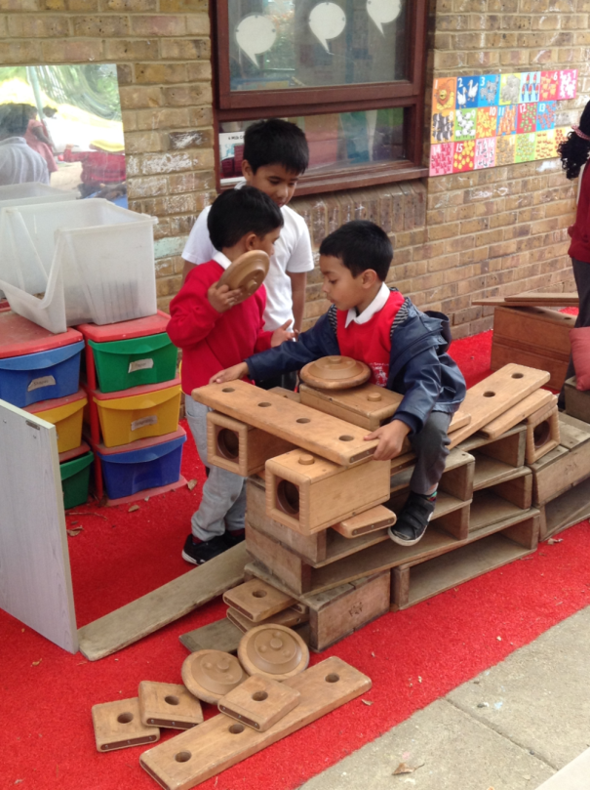
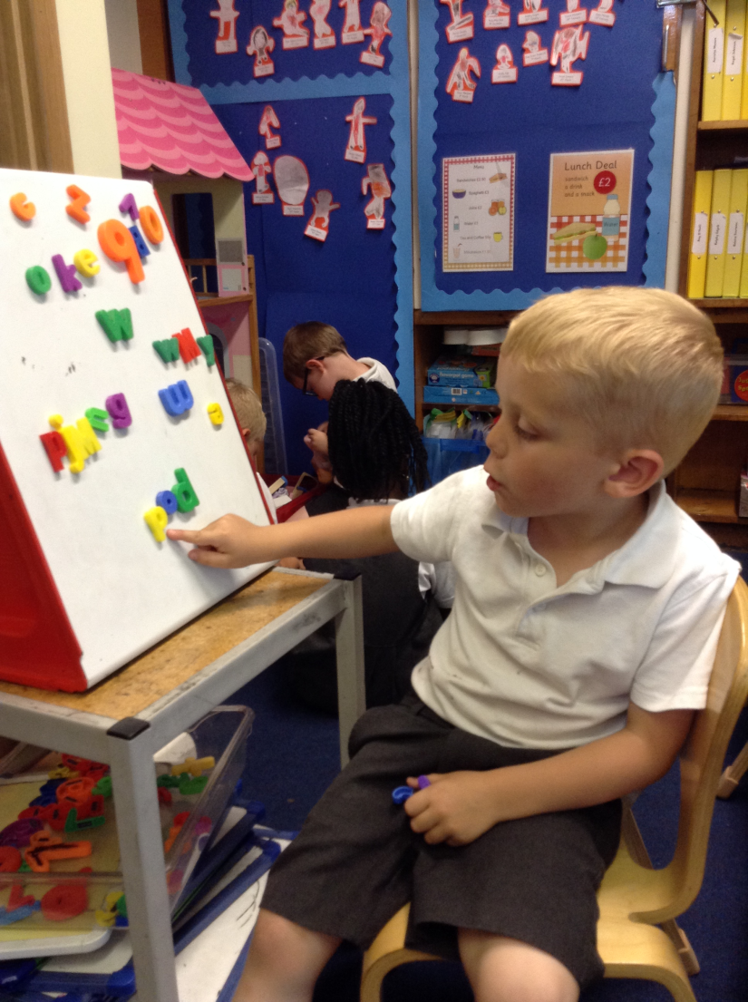

Key Stage 1 Curriculum
[Years 1 and 2]

The National Curriculum is followed in Key Stage 1. We use cross curricular planning to link subjects through Themes or Topics. Literacy and Maths are taught daily and linked to other subjects where possible.
Some strands of the curriculum are taught independently where they will not fit into the cross curricular plans. Music and drama are taught by specialist teachers.
We believe in educating the ‘whole child’ to become citizens of the future and pupil’s moral, personal and social development is an integral part of the curriculum. Additional information about the curriculum and how to support your child at home can be found on the school’s website www.villageinfants.com.

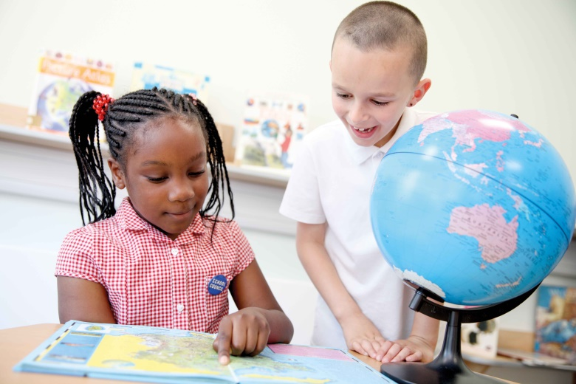

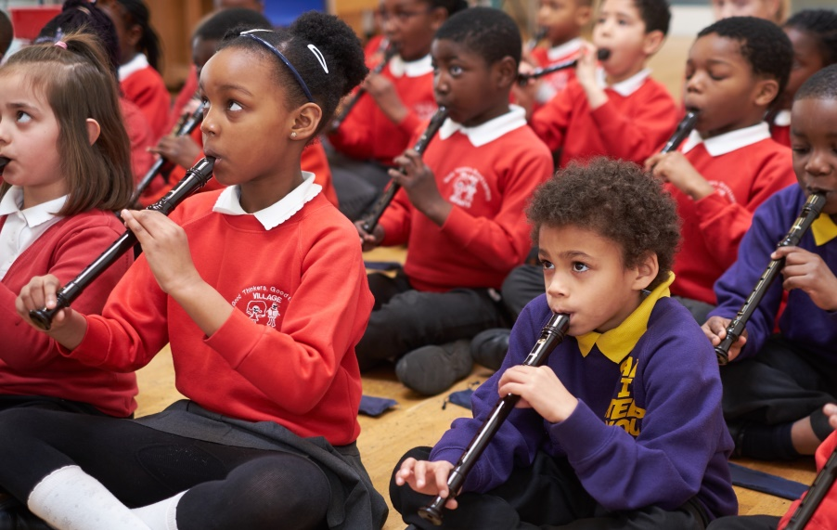
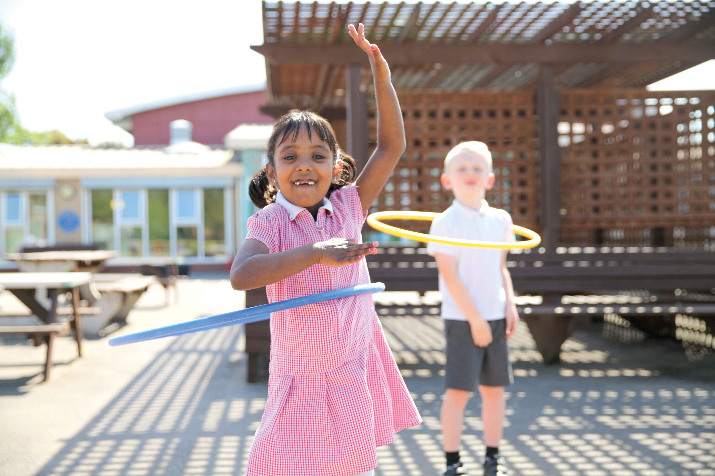

READING

“One of the best ways you can help your children learn and
learn to read is to share books with them. Here’s why:

They get to know the sounds, rhythms and words used
in the way we write. This is different from how we talk,
so hearing stories helps children learn how to read.

They think about the feelings of the characters in the book.
This helps them as they go about their own lives with other people.

They think about the ideas in the book.
This helps them to understand the world.

Sharing books and listening to what your children say
about them shows your children that you care about them,
you care about what they think and who they are.”

Michael Rosen
Writer and Poet
Children’s Laureate (2007-9)

READING

It’s never too early to support your child on their reading journey. Here are some activities to help them.

- Teach your child nursery rhymes and sing songs with them
- Spend time talking to your child
- Read books to your child and talk about the stories and the pictures

Throughout your child’s time at school continue to read to them and discuss stories, information books and poetry at a level beyond that at which they can read independently. This will develop a pleasure in reading, motivation to read and also extend your child’s vocabulary and understanding. Research has shown that the most successful readers at secondary school are children whose parents read to them throughout their primary years.

As well as reading to your child please find the time to listen to them read.
When your child brings a book home to read to/with you, please try to find a little time every day (10 minutes) to help your child. It is very important that you value this time:

- Turn off all screens
- Sit next to them and give them your full attention

Your child will be given half termly reading targets in their home/school reading diary. When you read to your child, or listen to them read please talk about the pictures, story and characters and encourage your child to relate what is happening in the book to their own lives. This ‘book talk’ will deepen their understanding of what they have read and develop their comprehension skills.

Always try to be positive and encourage your child. It is not easy for a child to learn all the skills necessary to become a confident reader. We realise that sometimes life is very busy but believe that making time to share and discuss books every day will make all the difference in your child’s reading journey. Please do not hesitate to speak to your child’s teacher for further support and ideas.
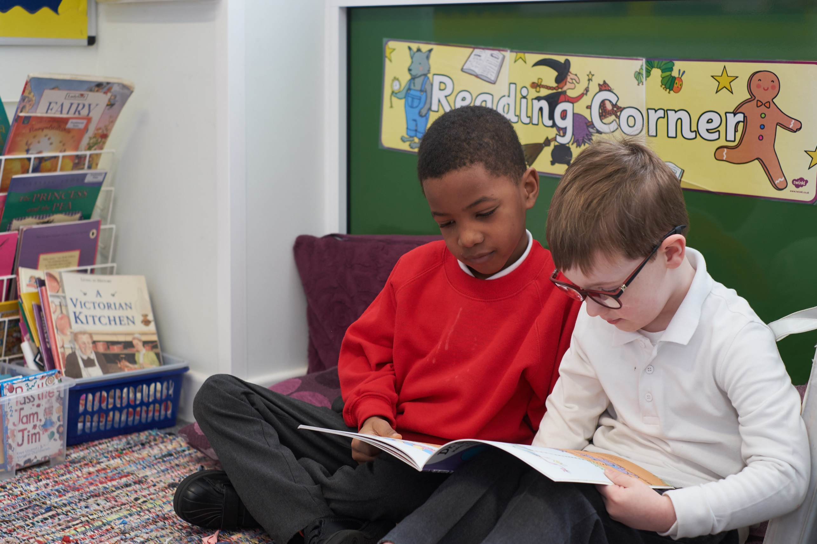

MATHS

Have you ever wondered why so many adults believe they are no good at maths?

At Village Infants we believe in giving children opportunities to provide them with a solid foundation that will not crumble when they advance through their school years. Being able to talk about numbers and explain their thinking is essential.

How can I help my child?
Below are just a few suggestions. See your child’s teacher for more ideas!

Talk with your child and have fun. Maths is all around you.

- Pre- number skills involve being able to think logically. A good task to help young children think and reason is to give them sorting activities. Sorting sweets such as Smarties or Skittles according to colour is fun! A healthier option could be sorting coins or toy cars. If they find this hard – show them and demonstrate accurate counting eg ‘we’ve got 4 red Smarties… if you eat one that will be one less and that will be 3.’

- For young children, have fun counting: stairs, jumps, wheels on cars, conkers, buttons, socks in the wash basket etc. Demonstrate and model good language such as ‘one more’ and ‘one less.’ The more they hear you talk about numbers… the more confident they will be.

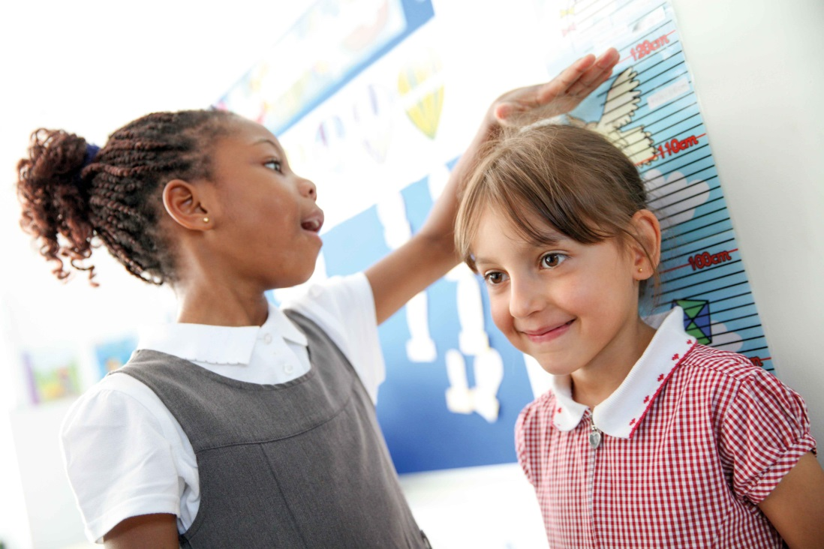

- Do not be in a hurry to get onto ‘big’ numbers! Instead spend time helping your child to really understand where a number belongs eg 5 is 1less than 6 and 1 more than 4.

- As your child grows more confident at school they will be introduced to the concepts of addition and subtraction. Now is the time to really see if they have a solid understanding of number and it is here that you can support them by encouraging them to talk about basic ‘sums.’ Look for example at the thinking that can evolve from the simple ‘sum’ of 3 + 4 = 7!!

3 | and | 4 | equals | 7

the difference | between | 7 | and | 3 | is | 4

7 | take away | 3 | leaves | 4

7 | subtract | 4 | equals | 3

4 | and | 3 | equals | 7

7 | is | 4 | more than | 3

4 | is | 3 | less than | 7

HELPING IN SCHOOL

We are always very pleased to welcome parents/carers/grandparents to help in school, supporting the children. We already have a group of helpers who are greatly valued by us and who find the experience rewarding.

Please contact the school office if you would like to volunteer in school.

Please note it is School Policy for volunteers to undergo enhanced safeguarding checks.

ASSEMBLIES

Although the school has no affiliation to any particular religious denomination, the main emphasis is on Christianity, with references being made to other religions and festivals. Assemblies also cover a broad range of topics including the school values, pupil well being and keeping safe, environmental issues and topical news.

Assemblies are led by the Headteacher or other members of staff. Any parent wishing to withdraw their child from assemblies must contact the Headteacher.

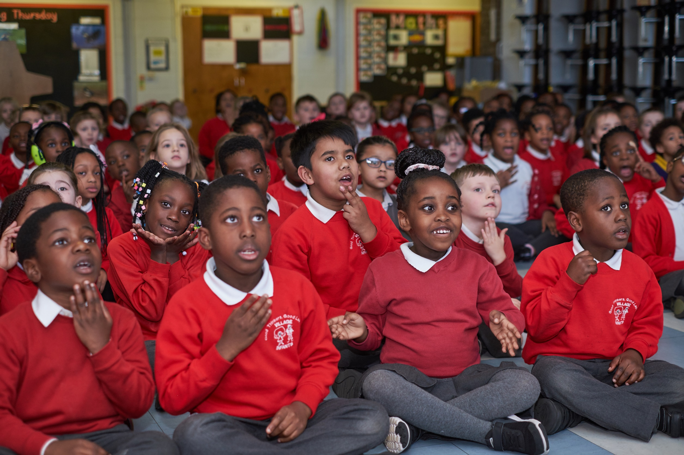

PHYSICAL EDUCATION

P.E. is a National Curriculum subject and all children must take part.
Children cannot be excused from P.E. unless they have a doctor’s letter, are in “plaster” or have stitches following an accident.
Please see the Headteacher if this happens.

Children will need a named P.E. kit. Please note our children wear a coloured P.E. t-shirt according to the Team they are in. You will be informed of your child’s Team Colour when they start school. The t-shirts are available to purchase from Premier Schoolwear 688-690 Becontree Avenue, Dagenham Essex RM8 3HD (opposite Morrisons).

P.E. kit in a bag as follows:-
Yellow/Green/Red/Blue round necked short sleeved T shirt [according to Team Colour]
Black shorts
Safe footwear [plimsolls or trainers]
Draw-string bag which can be hung on a coat peg.

Dance and gym are done in bare feet unless children have a verruca.

PLEASE NAME ALL ITEMS as the school cannot be held responsible for loss.

ATTENDANCE
Good attendance helps children make good progress in their learning and enjoy happy and confident relations with others. If children are not at school this puts them at a disadvantage not only with their learning, which they have to catch up with but also with their friendships, self-esteem and confidence.

At Village Infants our expectation is that your child attends school every day. If your child is unable to attend school please inform us on the first day of absence by telephone 02082706589.

If we do not have an explanation as to why your child is not attending school you will receive a ‘Parent Mail’ message asking you to contact the school immediately.

Please do not make doctors, dental or opticians appointments during school hours unless it is an emergency.

In the case of a long absence please contact the school to keep us informed of your child's progress.

Attendance Governors work closely with the school to improve attendance and punctuality. Our registers are inspected weekly and if they show persistent or unexplained absences for your child you may be contacted by the Governors’ Attendance Panel.

Authorised absence If your child has a valid reason for not being in school and you have informed us

Unauthorised absences – when a child is absent from school for unacceptable reasons ie: unauthorised holidays, shopping, hair cuts etc

For more detailed information about attendance please refer to our Attendance and Punctuality Policy which you will find on the school website www.villageinfants.com

Sickness and Diarrhoea
If your child has had sickness or diarrhoea they must stay off of school for 2 days after the last incident of sickness or diarrhoea.

Holidays taken in term time
In line with the Government and Local Authority recommendations we do not authorise holidays during term time. If you have an exceptional circumstance which warrants your child being absent from school you are asked to explain this in writing to the Headteacher and Governing Board 4 weeks prior to the requested absence

PUNCTUALITY

Late arrivals - children should be brought to the office where a late arrivals sheet must be filled in.
Punctuality is very important and persistent late comers will be reported to the Local Authority.
Children can find being late distressing as they miss out on the calm start to the day and also disturb the learning of other pupils in the classroom as they arrive.

Late collection - It is important that you are waiting to collect your child at the designated time.
Schools have a duty to report incidents of extreme lateness to Social Services.

SAFETY
Electronic gates:
- Pedestrian gates are closed between 9.15 – 3.00. Access via entry phone and exit by pressing the button next to the gate.
- Vehicle gates are closed all day for safety and security and are accessed via an electronic entry system.
- No vehicular access at all whilst children are coming into school or leaving school between 8.45 – 9.15 and 3.00 – 3.30.

PLEASE DO NOT

- Park on the school drive or in front of the electronic gate at any time.
- Bring cars into the school car park other than in an emergency. If you need to collect your child during school hours, please report to the office first.
- Allow scooters, bicycles or skateboards to be used in the school grounds.
- Bring dogs beyond the electronic green gate into the school grounds with the exception of guide dogs.
- Smoke on school premises. We would also ask parents not to use a substitute smoking device on the school premises.

Liability
Children in Nursery and School are encouraged to run and play, to paint, cut and stick; aprons are provided for the children to wear. Staff supervise at all times and encourage self-awareness of safety in the children, but at times the above activities lead to clothes being torn, dirtied or marked with paint or glue. The school cannot accept responsibility or offer compensation in such an event.

Safeguarding at the end of the school day
- We expect an adult to be waiting for their child when school finishes.
- Your child will be taken to the School Office at 3.20 if they have not been collected.
- We have a password system for keeping children safe.
- We will not allow them to leave the school with anyone under the age of 14
- Parents must inform the school office or the member of staff on the gate if their child is to be collected by anyone other than the usual adult. Please ensure the adult collecting your child has your child’s Password. We will not release any child if the password is unknown.

It is your responsibility to keep your child with you after they have been handed over to you. Please ensure they stay with you or hold your hand to ensure they do not get lost!

Mobile Phones
Please avoid chatting on your phone when you collect your child at the end of the day. This is a good time to make your child feel valued by talking with them.

E-Safety
Please see our website for guidance on keeping your child safe.

SMART HAND
Do not tell anybody your



School

Photo
Address

Name

Password

LUNCHTIME
Every child is entitled to a Free Hot School Dinner. Research in other Local Authorities has shown that children benefit from eating a hot school meal.

If you prefer to send a packed lunch to school for your child to eat at lunchtime, please choose foods that:

- They will enjoy eating
- Are healthy

Whilst we respect that you are the parent and do not like to judge your choices – we will work with parents to make sure that packed lunches are healthy. Please ensure that the packed lunch you provide includes at least one item from each of the following food groups

- Carbohydrates – bread, rolls, pasta, rice, crackers etc
- Protein – meat, fish, cheese, yoghurt
- Fruit
- Vegetables / Salad eg carrot sticks, cucumber rings, tomatoes etc

A simple example could be:
A cheese sandwich, fruit and some carrot sticks

Treats – please choose from one of the following:

- Crisps – preferably not every day
- Cakes
- Biscuit based bars

Lunch Boxes

Please name your child’s lunch box – we often have lots of boxes the same which can make it hard to children to know which is theirs.
Please ensure grapes, cherry tomatoes and other small fruits/vegs are cut in half to help prevent possible choking.

The Following are NOT allowed

- Fizzy drinks
- Drinks in glass containers
- Sweets or chocolates [chocolate biscuit based bars are ok]
- Foods containing nuts eg Nutella (sandwich filling and dips)


You may take your child home at lunchtime - please wait at the main door at the end of the morning session and your child will be handed over to you. Please bring your child back to the School Office at 1.15 pm.

Nut Free Zones

We have several children and staff at the school who are allergic to nuts which can be a life threatening condition. We have nut free zones in the school. The zones are classrooms and the dinner hall. Please do not put any foods containing nuts in your child’s lunch box.

BEHAVIOUR

Village Infant Rules

Are supported by our School Values of:

Perseverance Resilience Kindness Curiosity

They are child friendly and underpin all behaviour management. They are displayed in the school hall and frequently referred to in assemblies to embrace positive practice as well as investigate issues that need to be addressed. Rules are also displayed in every classroom and used as and when appropriate.

- Stop…. Think ….. Choose the right thing
- Be kind: Kind Hands Kind Feet Kind words
- Tell the truth
- Try your best
- Look after things

To Guide children towards keeping rules, we ask them to

Stop

Think

Choose the Right Thing

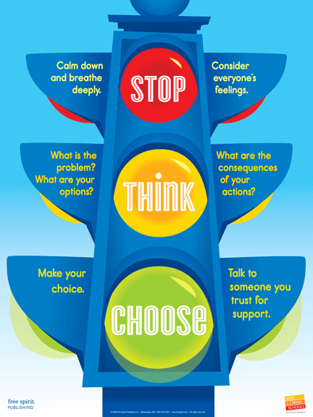

SCHOOL UNIFORM

It is expected that every child will wear school uniform every day.

Parents are requested to provide clothes in school colours as follows:-

Boys Poloshirts, Shirts - White.
Trousers or shorts - Grey
Tracksuit bottoms - Grey
School Sweatshirts - Red

Girls Poloshirts, Blouses - White.
Skirts, Pinafore Dresses, Trousers - Grey
Tracksuit bottoms - Grey.
School Sweatshirts - Red
School Cardigan - Red
Summer Dresses - Red and white gingham
check.

School Uniform with school logo can be ordered online at www.premierschoolwear.com. Free delivery to school every Wednesday for collection. Alternatively, you can place a click and collect order and then collect from:
Unit 7, Tonbridge Works,
Tonbridge Road,
Romford RM3 8TS

Alternatively uniform without the logo can be purchased from supermarkets eg Asda, Tesco etc
In addition, the following items can be purchased from the school office anytime:
- Book bags – we do not allow children to bring their books in rucksacks.
- Water bottles

Shoes
- Children should wear sensible flat black shoes or trainers
- No sandals
- If your child is unable to tie laces they must have footwear with Velcro fastenings

Socks must be worn with all footwear.

Jewellery
- Children should not wear any jewellery apart from a watch or stud ear-rings

PLEASE NAME ALL ITEMS OF CLOTHING, including shoes and outdoor coats, as the school cannot be held responsible for loss.

POLICY FOR PUPIL ILLNESS AND THE
ADMINISTRATION OF MEDICINE

1. Pupils who are unwell
Pupils should not be sent to school unwell.

If your child has had sickness or diarrhoea they must stay off of school for 2 days after the last incident of sickness or diarrhoea.

If a child is fit enough to be in school, we would expect the child to take part in all school activities, including P.E. Exceptions: If a child is in plaster due to a broken limb or a Doctor has made a written request please see Headteacher.

2. The Administration of Medicine
If a child suffers from asthma, the inhaler may be kept in their classroom. A first aider will supervise while the child self-administers the dose required at a time agreed with the parent. Parents will be required to sign a Consent Form to authorise this.

If your child requires prescribed medicine during the school day you must complete the ‘Authorisation for medicine to be taken in school Form’ before a first aider can administer the medicine to your child. Please collect the Form from the School Office.

3. Children who become unwell at school
If a child becomes unwell at school, it is the duty of parents to make arrangements to collect the child to take him/her home or to the doctor or hospital.

To this end, it is vital to have not only pupils' home telephone numbers, but parents’ work numbers and other emergency numbers, such as those of relatives.

In the case of serious injury or emergency, an ambulance will be called then parents rung, so that medical care is obtained.

4. Accidents and injuries in school – First Aid Procedures
The school has qualified First Aiders who will deal with minor accidents and injuries. Depending upon the nature of the injury you may or may not be notified.

Accident Book

- If your child has an accident or sustains an injury during the school day we will record the details in our School Accident Book and take one of the actions below.

Injuries above the neck
- Send home an Injury Slip explaining the injury this will be in your child’s book bag.
- Depending on the injury we might telephone you explaining the injury and giving you a choice to come and look at your child’s injury or collect them if it’s more serious.

Injuries causing concern
- We will telephone you explaining the injury and giving you a choice to come and look at your child’s injury or collect them if it’s more serious.
or
- Send home an Injury Slip explaining the injury this will be in your child’s book bag.

Minor Injuries
- If your child sustains a minor injury e.g grazes, bruises or knocks needing either a plaster or tender loving care this will be dealt with in our first aid area. You will not be notified.

999 Medical Attention
- In the event that your child has a serious injury and needs immediate attention we will first call an ambulance and then call you.

It is your responsibility to:

- Ensure the School Office has up-to-date emergency contact numbers at all times.
- Look in your child’s book bag for Injury Slips after school every day.

5. Head Lice infestation is a medical condition and should be treated promptly. We recommend regular combing of conditioner through the hair with a head lice comb to try to prevent infestation. Head lice spread rapidly and we will inform parents if we notice them.

Child Protection
Village Infants aims to work in close partnership with parents to support the children in every way possible. However, there is a clear responsibility on all schools to ensure they work together with other agencies to safeguard and promote the welfare of all children.

As a result, if concerns are raised within the school, or a child or parent reports a situation involving possible abuse, we are required to refer such matters to the appropriate Children’s Services, in line with Government and Barking and Dagenham Council policy.

We are committed to safeguarding and promoting the welfare of children and expect all staff and volunteers to share this commitment. Consequently all adults working in school are required to complete a DBS (Disclosure and Barring Service) Enhanced Police Check and all regular volunteers.

It may be helpful for parents to know that the Local Authority requires Head Teachers to report any obvious or suspected case of child abuse which includes non-accidental injury, severe physical neglect, emotional abuse and/or sexual abuse. This procedure is intended to protect children at risk and schools are encouraged to take the attitude that where there are grounds for suspicion it is better to be safe than sorry. This does mean that Headteacher’s risk upsetting some parents by reporting a case, which on investigation proves unfounded. In such circumstances, it is hoped that parents, appreciating how difficult it is for Headteacher’s to carry out this delicate responsibility, would accept that the Headteacher was acting in what was believed to be the child’s best interests.

You can discuss concerns about your child with your child’s class teacher but if you have concerns about another child please contact the following designated staff in our school:

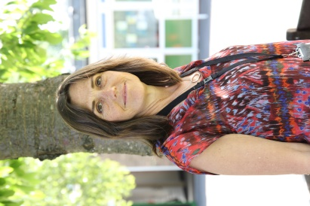
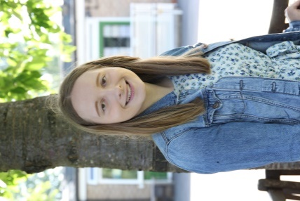

Mrs Rix – Acting Deputy Head
Deputy Child Protection Co-ordinator

Ms Y Cattle - Acting Head Teacher
Child Protection Lead

SPECIAL EDUCATIONAL NEEDS and DISABILITIES

Village Infants is an inclusive school. We want all pupils to have a well balanced education, with opportunities to learn, play and develop alongside each other to reach their full potential. We are committed to supporting learners when they experience difficulty in accessing the school curriculum and daily routines.

We aim to provide for children with S.E.N.D. in 4 key areas –
- Early intervention - to ensure pupils who have difficulties learning receive help as soon as possible
- Remove Barriers to learning – modifying the curriculum when necessary and providing a flexible approach to learning styles and classroom organisation
- Raising expectations and achievements – setting appropriate targets and monitoring progress.
- Delivering improvements in partnership – with both parents and agencies which might be involved in supporting your child e.g. occupational therapist, school nurse, behaviour support team, speech therapist etc. We want parents to have confidence that their child’s needs are being met effectively. Parents are actively encouraged to participate in sharing their children’s targets which are recorded on an Personal Learning Plan. These targets are regularly assessed and reviews held with parents at least 3 times a year.

We appreciate that it can be extremely worrying for parents if they feel their child’s needs are not being met. Please tell your child’s class teacher if you have any concerns. If necessary they will arrange a meeting for you with the school SENDCo – Mrs Byron.

Accessibility Plan
The current plan is from 2020 – 2024 and can be found on the school website
www.villageinfants.com

COMPLAINTS PROCEDURES

It is the sincere hope of the Barking and Dagenham Children’s Services, the Village Infants School Governing Board and the Headteacher, that parents' concerns about their children's education can be dealt with swiftly and fairly at school level.

We are always willing to discuss any problems or concerns you may have. By tackling a problem together we can often prevent it from becoming more serious. In the first instance please share all concerns with the class teacher. If the issue remains unresolved please follow our complaints procedure as outline in our Complaints Policy on the school website [www.villageinfants.com].

SCHOOL TERM AND HOLIDAY DATES FOR THE SCHOOL YEAR 2022 – 2023

AUTUMN TERM 2022
Friday 2nd September | Teacher Training Day
Monday 5th September | Children return to school
Friday 21st October | Break up, half term
Monday 31st October | Children return to school
Tuesday 29th November | Teacher Training Day
Thursday 22nd December | Break up, Christmas
SPRING TERM 2023
Friday 6th January | Teacher Training Day
Monday 9th January | Children return to school
Friday 10th February | Break up, Half Term
Monday 20th February | Children return to school
Friday 31st March | Break up, Easter
SUMMER TERM 2023
Monday 17th April | Teacher Training Day
Tuesday 18th April | Children return to school
Monday 1st May | Bank Holiday
Friday 26th May | Break up, half term
Monday 5th June | Teacher Training Day
Tuesday 6th June | Children return to school
Friday 21st July | Break up, Summer
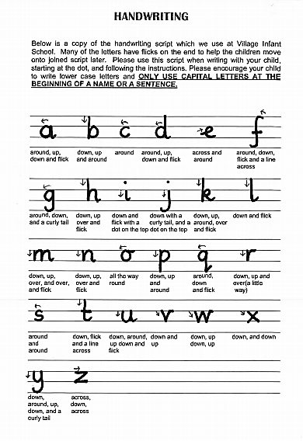

Children Learn What They Live

If a child lives with criticism
He learns to condemn.
If a child lives with hostility
He learns to fight.
If a child lives with ridicule
He learns to be shy.
If a child lives with shame
He learns to feel guilt.
If a child lives with tolerance
He learns to be patient.
If a child lives with encouragement
He learns confidence.
If a child lives with praise
He learns to appreciate.
If a child lives with fairness
He learns justice.
If a child lives with security
He learns to have faith.
If a child lives with approval
He learns to like himself.
If a child lives with acceptance and friendship
He learns to find love in the world.

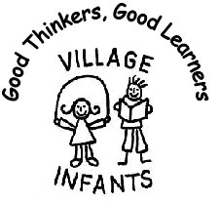
Village Infants School
Home School Agreement
Pupils I will do my best:

- To do my best work every day
- To keep the School Rules
- To be kind
- To walk inside school
- To use a quiet voice in school
- To ask questions when I do not understand

Pupil’s signature………………………………………. Date: …………………

At School we will do our best :

- To be open and welcoming
- To encourage children to do their best at all times
- To encourage children to look after things and care for the world
- To inform parents of their child’s progress at regular meetings
- To inform parents of what the teachers aim to teach the children each term
- To create a culture where children can ask questions and talk about their learning
- To encourage children to develop the core values of perseverance, resilience, kindness and curiosity
Headteacher’s Signature: Date: May 2021

At Home I will do my best:

- To make sure that my child arrives for school safely and on time
- To make sure my child is collected on time
- To follow the school’s Attendance and Punctuality Policy [ attached]
- To send my child to school in school uniform
- To label my child’s clothes clearly with their name
- To make sure my child does not wear jewellery to school – other than a watch and small stud ear-rings
- To send my child to school with PE kit with each item of clothing labelled clearly with their name in a draw string PE bag
- To send my child to school with their book bag every day
- To support my child with their learning eg

  - read my child stories
  - hear my child read their reading book every day and discuss the story/book with them
  - share topic plans with my child by following through the parent suggestions that teachers provide
- To support the school rules and encourage my child to behave responsibly
- To comply with school procedures and policies

Parent’s Signature: ……………………………………… Date: …………………

